**DAILY ONLINE ACTIVITIES SUMMARY**

|  |  |  |  |  |  |  |  |  |
| --- | --- | --- | --- | --- | --- | --- | --- | --- |
| **Date:** | **16-6-2020** | | | | | **Name:** | **Prajna** | |
| **Sem & Sec** | **8th sem ‘B’** | | | | | **USN:** | **4AL16CS067** | |
| **Online Test Summary** | | | | | | | | |
| **Subject** | | **BDA** | | | | | | |
| **Max. Marks** | | **30** | | **Score** | | | **28** | |
| **Certification Course Summary** | | | | | | | | |
| **Course** | **Introduction to python programming** | | | | | | | |
| **Certificate Provider** | | | **Great learning** | | **Duration** | | | **2hrs** |
| **Coding Challenges** | | | | | | | | |
| **Problem Statement:**1**.** Write a python program to find list are circular identicle. | | | | | | | | |
| **Status: Completed** | | | | | | | | |
| **Uploaded the report in GitHub**  **GitHub link:** | | | | | **Yes**  **https://github.com/alvas-education-foundation/prajna_k** | | | |
| **If yes Repository name** | | | | | **prajna_k** | | | |
| **Uploaded the report in slack** | | | | | **yes** | | | |

Online Test Details: (Attach the snapshot and briefly write the report for the same)

Certification Course Details: (Attach the snapshot and briefly write the report for the same)

Coding Challenges Details: (Attach the snapshot and briefly write the report for the same)

1)online test

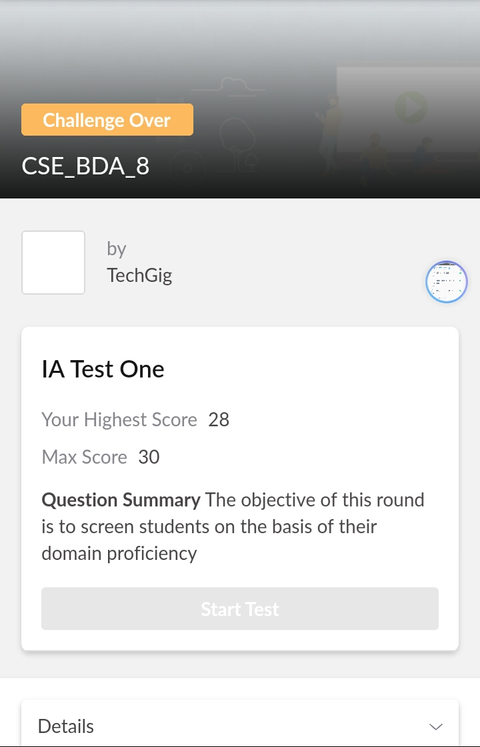

2) certification course

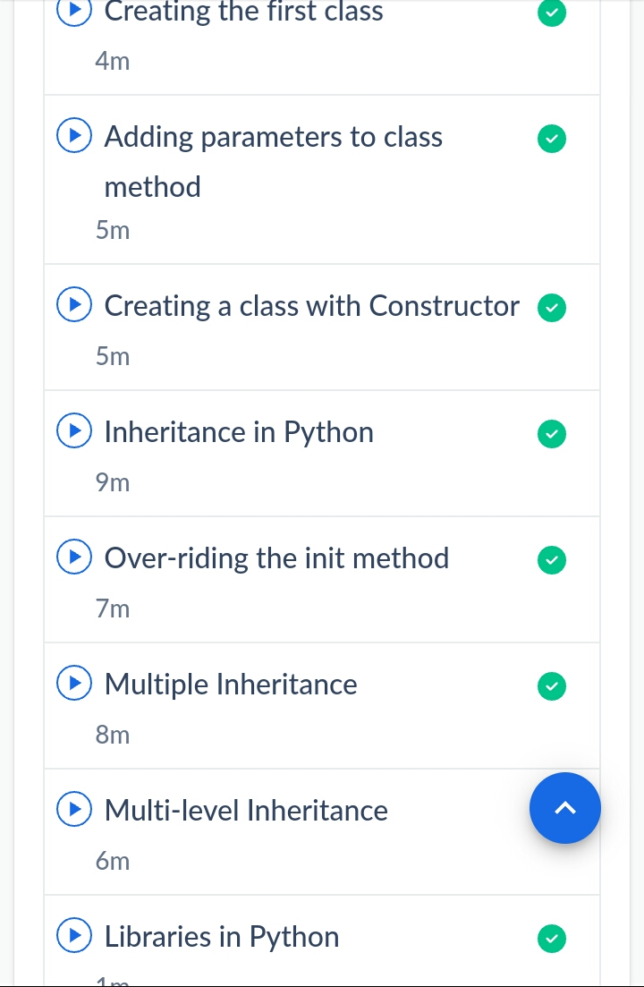

3) coding challenges

Program 1

list1 = [10, 10, 0, 0, 10]

list2 = [10, 10, 10, 0, 0]

list3 = [1, 10, 10, 0, 0]

print('Compare list1 and list2')

print(' '.join(map(str, list2)) in ' '.join(map(str, list1 * 2)))

print('Compare list1 and list3')

print(' '.join(map(str, list3)) in ' '.join(map(str, list1 * 2)))

|  |
| --- |
|  |
|  |  |
|  |  |
|  |  |
|  |  |
|  |  |